Methods Memo - Data Wrangling Challenges and Solutions
During the data wrangling stage of our project, we worked with several large public datasets covering walkability, food insecurity, obesity, and food access across Texas. Bringing these sources together required multiple rounds of cleaning, filtering, and standardization.. The sections below outline the five main challenges we encountered, followed by the code used to prepare our datasets and how we addressed them.

- Inconsistent Geographic Boundaries Across Datasets
Some datasets used county boundaries, while others were reported at the metro-area level, because metro areas combine several counties; the datasets were not aligned geographically, which made comparisons difficult.
walk_tx_df = pd.read_csv(walk_tx_path)
county_fp_df=pd.read_csv("COUNTYFP_TX.csv")
merged_df=walk_tx_df.merge(county_fp_df,how='left')
How We Solved It:
We grouped the necessary counties into their corresponding metro areas so that all datasets aligned on the same boundary.

- Multiple Data Entries for Individual Counties or Geographic Location
Some datasets contained multiple entries for a single county or geographic area. These duplicates had to be resolved so values were not overstated, and counties did not appear more than once in the final dataset.
new_walk_tx_df = merged_df.groupby(['Texas County']).apply(condense_function).reset_index()
How We Solved It:
We identified counties and metro areas with duplicate entries and combined them into a single consolidated record.

- Walkability Using State Names VS. Food Access Using State Numbers
The walkability dataset lists states by name, while the food access dataset uses numeric state codes. Because the formats were different, they could not serve as consistent join keys.
county_fp_df=pd.read_csv("COUNTYFP_TX.csv")
merged_df=walk_tx_df.merge(county_fp_df,how='left')
How We Solved It:
We standardized the state fields so that both datasets used the same type of identifier before merging.

- Condensing Datasets
Each dataset included many rows that were not relevant to our analysis. To simplify the files, we selected only the necessary columns and filtered the rows to retain only the Texas counties. This step also prepared the walkability data for grouping at the metro-area level.
walk_df=pd.read_csv("EPA_SmartLocationDatabase_V3_Jan_2021_Final.csv")
walk_tx_df=walk_df[walk_df['STATEFP']==48]
walk_tx_df.to_csv('WalkabilityTX.csv',index=False)
How We Solved It:
We narrowed the datasets to only the fields needed for the project and limited the scope to Texas counties, which made the rest of the wrangling process cleaner and more efficient.

- Recalculating Data Values In the Process Of Condensing Data
Once duplicates were grouped, some values needed to be recalculated. This included population totals, employment totals, wage percentages, household counts, and weighted walkability scores. These recalculations were necessary because the consolidated rows represented multiple smaller geographic units.
def condense_function(df):
new_df = pd.Series({
'COUNTY_POP': df['TotPop'].sum(), 'COUNTY_EMP': df['TotEmp'].sum()...
How We Solved It:
We recomputed totals. percentages, and other values to ensure the data accurately reflected each county.

Database Schema
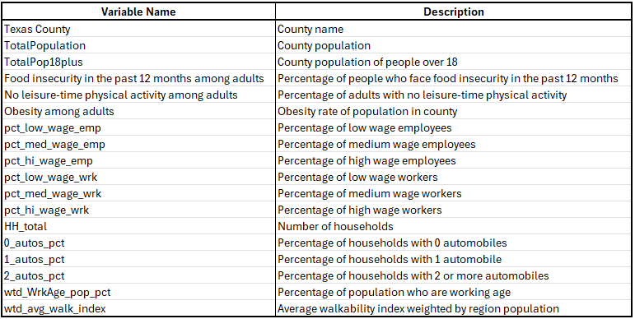
Final SQL Query
query="SELECT 'Texas County', 'TotalPopulation', 'TotalPop18plus', 'Food insecurity in the past 12 months among adults', 'No leisure-time physical activity among adults', 'Obesity among adults', 'pct_low_wage_emp', 'pct_med_wage_emp', 'pct_hi_wage_emp', 'pct_low_wage_wrk', 'pct_med_wage_wrk', 'pct_hi_wage_wrk', 'HH_total', '0_autos_pct', '1_autos_pct', '2_autos_pct', 'wtd_WrkAge_pop_pct', 'wtd_avg_walk_index' FROM Merged_Main;"

DataFrame Profile
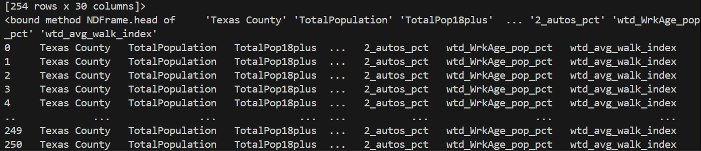
Summary
By filtering the datasets to Texas, aligning the geographic boundaries, fixing duplicate entries, converting FIP codes to county names, and condensing the walkability data, we created a consistent structure that could merge into a single dataset. These steps removed inconsistencies across sources and produced a reliable foundation for analysis.

